**DEVELOPING A RESPONSE TIME MODELING APPROACH FOR CANCER-RELATED COGNITIVE DECLINE ASSESSMENT**

by

BRYANNA LE SCHEULER, M.S.

DISSERTATION PROPOSAL

Presented to the Graduate Faculty of

The University of Texas at San Antonio

in Partial Fulfillment

of the Requirements

for the Degree of

DOCTOR OF PHILOSOPHY IN PSYCHOLOGY

COMMITTEE MEMBERS:

Joseph Houpt, Ph.D., Chair

Edward Golob, Ph.D.

Qiliang He, Ph.D.

Daniel Hughes, Ph.D.

THE UNIVERSITY OF TEXAS AT SAN ANTONIO

College of Health, Community, and Policy

Department of Psychology

**CHAPTER ONE: CANCER-RELATED COGNITIVE DECLINE**

Cancer is a devastating disease that impacts an astounding number of people. According to the World Cancer Research Fund International (2023), there were 18.1 million new cancer cases diagnosed worldwide in 2020. The American Cancer Society estimated that 1,958,310 new cancer cases would be diagnosed in the United States throughout 2023, resulting in the United States being the second-highest contributor to worldwide cases (Siegel et al., 2023; World Cancer Research Fund International, 2023). To put this in more relatable terms, there is nearly a 40% chance of being diagnosed with an invasive form of cancer throughout a person’s lifetime (40.9% for men, 39.1% for women; Siegel et al., 2023). On a more positive note, cancer survivability has substantially improved over time. While the average 5-year survival rate for all cancers was 49% in the 1970s, the 5-year survival rate in the 2010s was 68% (Siegel et al., 2023). The American Cancer Society projected that if cancer mortality rates had remained constant from their spurious peak in 1991, there would have been 3,820,800 additional cancer deaths over the last two decades (Siegel et al., 2023). The advancements in screening diagnostics and cancer treatments have helped millions of people live to experience life after cancer. However, with this ever-growing number of people adjusting to life post-cancer diagnosis, a new need has arisen: how to improve patient and survivor quality of life. In addition to battling cancer, these individuals face a litany of side effects, including weight changes, fatigue, depression, anxiety, and cancer-related cognitive decline (CRCD; Parada et al., 2023). This impairment, commonly referred to as “chemo-brain,” has become a focus of research in the last twenty years, due to the substantial impacts it can have on a patient’s life. In interviews, patients often describe forgetting common words or tasks, struggling with directions, and no longer being able to multitask (Wu et al., 2019). The ripple effect of these symptoms can grow immensely, as CRCD has been linked to loss of social relationships, medication nonadherence, and lower survival rates (Franco-Rocha et al., 2023). Parada et al. (2023) reported that up to 53% of cancer survivors experience cognitive difficulties when returning to school or work, which can add financial strain. CRCD can even become a safety concern, as Yuen et al. (2008) reported a possible association between CRCD and poorer driving performance. As the ramifications of these side effects of cancer have become more apparent and the number of people battling CRCD has grown, researchers have raced to understand this dysfunction.

While it has been well established that CRCD affects the cognitive domains of working memory, attention, and executive function, and to a lesser extent, psychomotor speed, visuospatial abilities, and verbal fluency, understanding the cause of CRCD has remained more elusive (Hermelink, 2015). Originally, CRCD was assumed to be a side effect of the neurotoxicity of chemotherapy, hence the moniker of “chemo-brain,” (Hermelink, 2015). However, as researchers shifted from cross-sectional designs to more longitudinal studies in the mid- and late-1990s, evidence began to build that CRCD was present before treatment was ever administered (Hermelink, 2015).In response to the growing uncertainties presented by this wave of CRCD research, the Hurricane Voices Breast Cancer Foundation gathered 30 healthcare professionals and three patient advocates from around the world to attend a workshop in Banff, Canada on April 23, 2003 (Tannock et al., 2004). This conference, later referred to as the Banff Conference, became a major point of consolidation, with the components of this conference having a ripple effect through all future CRCD research. One such component was the comparison of CRCD to sickness behavior. At a smaller American CRCD workshop in 2001, researchers and clinicians had discussed the similarities between CRCD and the animal model of sickness behavior, which refers to a cluster of symptoms including gastrointestinal difficulties, pain, sleep disturbances, distress, and decreased environment exploration (Cleeland et al., 2003). Importantly, the sickness behavior model is well studied, with a strong understanding of the biological processes involved. This theoretical basis was expanded upon at the Banff Conference, providing an avenue to assess the multitude of biological mechanisms that could cause CRCD, by relying on the groundwork established in animal sickness behavior. This began a race to understand the biology of CRCD, which many researchers believe to be the most crucial approach to CRCD research. For example, Chae et al. (2016) stated that “the lack of understanding of the biological mechanisms underpinning [CRCD] remains the major impediment to the development of effective management strategies,” (p. 10). Understanding these biological mechanisms is nontrivial, as there a vast number of potential causes, that interact in complex ways.

Unfortunately, this race towards understanding the underlying biological mechanisms of CRCD is faced by a second substantial roadblock: the difficulty of measuring this cognitive impairment. Occurrence rates of CRCD can range between 15% to 75%, depending on the study, with subjective and objective measures rarely correlating (Hermelink, 2015; Parada et al., 2023; Wefel et al., 2011). The Banff conference resulted in the production of the Functional Assessment of Cancer Therapy-Cognitive (FACT-Cog) scale, with the current version (FACT-Cog version 3), becoming the most commonly utilized self-report assessment of CRCD used to this day (Henneghan et al., 2021a; Tannock et al., 2004). Even for this heavily relied upon tool, there are many concerns. At the origins of the FACT-Cog, the authors cautioned that a patient’s mood would greatly impact the results (Tannock et al., 2004). The impact of perception is often demonstrated in CRCD research, as self-report CRCD ratings often rise after cancer survivors return to normal school or work, even though there is little theoretical rationale or evidence to suggest that symptoms would get worse after survivors are healthier (Von Ah et al., 2018). In 2011, the International Cognition and Cancer Task Force (the organization created to centralize and direct CRCD research) released their recommendations for CRCD assessment, and discouraged the use of self-report measures, due to their lack of validation. Instead, the task force recommended researchers rely on objective measures (Wefel et al., 2011).

Despite the International Cognition and Cancer Task Force’s endorsement of objective measures for CRCD, there are many issues in this sector as well. The authors promoted the use of the Hopkins Verbal Learning Test-Revised to assess learning and memory, the Controlled Oral Word Association to evaluate speeded lexical fluency and executive function, and the Trail Making Test to measure psychomotor speed and executive function (Wefel et al., 2011). Notably, Wefel et al. (2011) acknowledged that other assessments (such as the Brief Test of Attention and WAIS-III Letter Number Sequencing) had been discussed, but did not meet their requirements, resulting in them opening the door for researchers to select their own measures for working memory and attention. This open door may actually be a piece of the problem. Across the 32 articles reviewed for this project that included the tool used, 61 different assessments were utilized, all claiming to measure CRCD (see Appendix A). While this list of measurements is quite expansive, covering a wide array of domains, not all the assessments have illustrated significant differences in cognitive impairment for cancer patients. Whether the lack of significant differences in some of these studies is because there is no impairment to be found or if it was not an assessment well-tailored to CRCD is difficult to say, as these assessments are rarely used multiple times.

This history of assessment difficulty highlights the need to reconsider the tools we are using when trying to understand what causes CRCD. Just like with gardening, the tool we use will impact the fruits of our labor. Imagine two farmers: one plows his field with a tractor, the other works his field with a spade. Working with a tractor is undeniably faster, but the farmer will not directly observe every plant, and the health of the plants will only be measured by the field’s overall production. Working with a spade is substantially more time consuming, but allows a farmer to collect more data per plant, such as height, number of leaves, and production rate. Both approaches will provide a crop, and there will be scenarios where each tool will better serve the farmer. If, for example, a farmer wants to understand what helps or hinders plant health, using a spade will allow the farmer to collect more data on each plant, and better understand what drives changes in plant growth. Applying this framework back to CRCD, is it possible that we have been using the proverbial tractor, when we could be better served with a spade? Could shifting to a tool that allows us to account for more information about each individual improve our understanding of what drives cognition changes? The goal of this project is to assess how selecting a more specific technique will allow us to measure changes in cognition, so we can build on our understanding of what causes CRCD.

**Contributing Factors**

As previously stated, one of the difficulties slowing progress in determining the underlying cause of CRCD is the vast array of factors contributing to this form of dysfunction. The list of postulated CRCD contributors includes the cancer treatment, the cancer itself, genetic susceptibility, traits of the patient, and mental health factors. While these components do not exist in a vacuum and certainly interact, separately assessing how each factor contributes to cognitive dysfunction can elucidate the complexities of CRCD.

***The Damage of Cancer Treatment***

The direct neurotoxicity of cancer treatment has continued to be considered a major contributor to CRCD, with the potential routes to direct brain damage representing a large portion of CRCD research. As an immune-privileged site, the brain is heavily dependent on the tightly packed endothelial cells that make up the blood-brain barrier (BBB) to prevent the sensitive tissue from exposure to any toxic substances in the bloodstream (Russo & McGavern, 2015). While the BBB can block substances with a molecular weight of at least 500 daltons, smaller molecules can slip past (Wu et al., 2019). In addition, chemotherapeutic agents can damage the BBB, compromising the junctions and allowing neurotoxic agents to pass through and damage the cerebral parenchyma. Wardill et al. (2016) reported that after intravenous injection, the chemotherapy agents bis-chloroethyl nitrosourea (BCNU), paclitaxel, and 5-fluorouracil were detected within the cerebral parenchyma of rodents and primates, illustrating the susceptibility of the BBB, and the potential for direct neurotoxic effects. Additionally, chemotherapeutic and radiation agents can be extremely damaging to DNA. Ren et al. (2019) reported that in “80% of human cancers, the immortal phenotype of cancer cells is due to an increase in telomerase activity,” so many cancer treatments are designed to target this telomere-shortening enzyme (p. 1090). Unfortunately, these treatments cannot differentiate between a tumor cell and a healthy cell, leading to dysregulated telomere shortening in numerous cells (Ren et al., 2019). This damage to DNA then leads to apoptosis and cell death, even within the central nervous system (Ren et al., 2019). This neuronal death is reflected in structural changes, as magnetic resonance imaging (MRI) studies frequently report reduced volume in the hippocampus, an area crucial to learning and memory (Orchard et al., 2017). In a functional MRI (fMRI) study with oncology patients, Wang et al. (2016) found significantly reduced activation in the right dorsolateral prefrontal cortex during an n-back assessment for working memory, as compared to healthy controls. The authors also reported hypoactivation in the left hippocampus during a visual recognition task, building evidence that structural damage to areas related to memory could be contributing to CRCD (Wang et al., 2016). It is important to note, however, that the self-report measures they utilized (including FACT-Cog) were not significantly correlated with the neuroimaging results, illustrating the difficulties in CRCD measurement.

In addition to directly damaging neural tissue, cancer treatments may also hinder the brain’s ability to restore itself by impairing neurogenesis. Though most neurons are non-dividing (in the adult brain), three special regions, the subgranular zone of the dentate gyrus of the hippocampus (the most important of the three), the stratum, and the subventricle zone of the lateral ventricles, exhibit neurogenesis, providing new neurons and supporting cells to recover from regular damage (Nguyen & Ehrlich, 2020). Thus, as cancer treatments are connected with hippocampal degradation, there is a possibility that neurogenesis is also impacted. Gibson and Monje (2021) acknowledged that impaired hippocampal neurogenesis has become a controversial potential cause of CRCD, as a baseline level of healthy neurogenesis has not been established. While the exact mechanisms and thresholds have yet to be determined, Nguyen & Ehrlich (2020) reported that a variety of common chemotherapy agents, including doxorubicin, paclitaxel, and cisplatin, were correlated with memory impairment and reductions in neurogenesis protein markers, such as BrdU and doublecortin. Similar results have been seen with reductions of brain-derived neurotrophic factor (BDNF), a growth factor that promotes neurogenesis, after treatment administration (Nguyen & Ehrlich, 2020; Yap et al., 2021). Future research may be able to delineate how cancer treatments can inhibit neurogenesis, prevent neuronal recovery, and impact CRCD.

A third route between cancer treatment and CRCD is the altering of the communication system in the brain. Gibson and Monje (2021) reported that cranial irradiation in rodents led to reductions in the length, density, and branching of hippocampal dendrites, and overall reductions in the number of spines. Nguyen and Ehrlich (2020) reported similar dendritic pruning in the cingulate after the administration of doxorubicin, fluorouracil, and cisplatin. On the other side of the synaptic cleft, neurotransmitters can be impacted as well. In a study on brain slices from mice treated with the chemotherapeutic agent carboplatin, Kaplan et al. (2016) reported that the uptake of both serotonin and dopamine was diminished, despite the lack of changes in reserve pool content, indicating that these neurotransmitters were not being released efficiently. In a third blow to transmission, treatments can also impact myelin plasticity, and hamper the maintenance of long-term potentiation (Mounier et al., 2020). Through the use of transmission electron microscopy, Geraghty et al. (2019) demonstrated a thinner myelin sheath in mice exposed to methotrexate chemotherapy than in healthy controls. In combination, chemotherapy can limit a neuron’s ability to send, carry, and receive a message, severely impacting cognition. In their study with mice trained to complete a 5-choice reaction time task, Huo et al. (2018) found that administration of cisplatin resulted in a reduction of synaptic integrity markers and an omission-related change in the percentage of correct responses. The authors proposed that by altering neurotransmission, chemotherapy can cause attention impairments, one of the key components of CRCD. While the heavy reliance on dissection techniques for this potential avenue presents a difficulty for replication with human studies, the results from animal models raise the possibility that treatment-driven changes to neurotransmission may impact CRCD in humans.

***Treatment Regimen***

There is an incredibly wide variety of chemotherapeutic agents, all designed to target different components of cancer cells, opening the possibility for different impacts on cognition. Mounier et al. (2020) conducted a review on the types of chemotherapies and presented links to the associated cognitive impairments. Hormone therapies, such as tamoxifen, stop or alter the hormones central to certain cancers, such as breast, prostate, or endometrial cancer. Mounier et al. (2020) reported that tamoxifen was related to impaired retrieval functions in mice and impaired verbal fluency, memory, processing speed, and visuospatial functioning in humans. A second class of chemotherapy drugs, antimicrotubule agents, keep the cytoskeleton of the cell in one shape, preventing mitosis and proliferation. These drugs, including paclitaxel and docetaxel, have been a source of debate in CRCD research, as cognitive deficits are not always present (Mounier et al., 2020). In rats and mice, antimicrotubule agents have been associated with impaired rule learning and object recognition (Mounier et al., 2020). In human studies, paclitaxel has been related to behavior changes, hallucinations, and confusion (Mounier et al., 2020). Another class of chemotherapy drugs, alkylating agents, are designed to attach an alkyl group to the guanine base of DNA, keeping the cell from reproducing and leading to apoptotic cell death (Mounier et al., 2020). This class of agents, including cyclophosphamide, ThioTEPA, and oxaliplatin, was linked to impaired memory retention and novel object recognition in mice (Mounier et al., 2020). The class of chemotherapy agents known as antimetabolites masquerade as metabolites to trick cancer cells into using the slightly altered version of the DNA-building molecule, preventing any further replication. These drugs, including methotrexate and 5-fluorouracil, were associated with impaired memory (usually spatial memory) and learning in rats (Mounier et al., 2020). The final class of chemotherapy drugs, the DNA-breaking cytotoxic antibiotics, such as doxorubicin, have been known to impair avoidance conditioning in rats (Mounier et al., 2020). The direct effects of alkylating agents, antimetabolites, and cytotoxic antibiotics in humans are difficult to tell, as they are rarely used separately from other agents. While these combinations exhibit the same impairments in learning and memory established with the other treatments, they are also linked to impaired executive function (Mounier et al., 2020). Determining whether impaired executive control is caused by a specific chemotherapeutic drug or if it is a unique result of combining agents presents another avenue for future CRCD research.

An additional layer to understanding the impact of chemotherapy treatments on CRCD is introduced by the dosage and length of treatment. Myers et al. (2008) reported that while methotrexate is not associated with neurotoxicity at lower doses, higher doses can cross the BBB. The importance of dosage is not restricted to antimetabolites, as studies with the alkylating agent cisplatin have shown a relationship between dosage and the volume and speed of dendritic pruning (Gibson and Monje, 2021). As chemotherapy damage increases, so does impairment. In a study assessing mice over three time points, Tang et al. (2022) found that stronger doses of paclitaxel maintained cognitive dysfunction for longer periods of time. The accumulation of chemotherapy in the system is also important, as most treatments require multiple administrations or cycles. When evaluating breast cancer patients across multiple cycles, Durán-Gómez et al. (2022) found that the number of cycles was significantly related to the FACT-Cog subscales of Perceived Cognitive Impairment, Quality of Life, Perceived Cognitive Ability, and Comments from Others. Similarly, there was a significant inverse relationship between the number of cycles and scores on a phonological and semantic verbal fluency task (Durán-Gómez et al., 2022). It is worth noting that this study did find a significant correlation between FACT-Cog and the neuropsychological verbal fluency assessment (Durán-Gómez et al., 2022). While these studies on the impact of dosage on CRCD are still very new, they raise the possibility that dosage could be even more important than chemotherapy type.

While chemotherapy is a staple of cancer treatment, it is not the only regimen that impacts CRCD. As Nagtegaal et al. (2020) reported the thinning of cortical thickness depended on radiation dose, the dosage of radiation could be just as important as the dosage of chemotherapy. When assessing the effects of radiation dose and location on CRCD, Gan et al. (2011) found a significant correlation between radiation dose to the temporal lobes and memory encoding. The authors also reported a statistically significant correlation between radiation doses to the cerebellum and coordination scores on the Pegboard test (Gan et al, 2011). Interestingly, there was not a significant difference between the group who received only radiation and the group who received radiation and chemotherapy, illustrating that radiation alone is sufficient to induce CRCD (Gan et al, 2011). This raises the question of what other cancer treatment regimens could impact CRCD. For example, there is preliminary evidence that stem cell transplants can impact cognitive impairment, even for two years post-treatment (Harrison et al., 2021; Wu et al., 2019). Though research into the cognitive impacts of stem cell transplants is still in its infancy, these early correlations illustrate that there is a wider variety of cancer treatment regimens that could impact CRCD.

***The Impact of Cancer Development***

Challenging the original expectations that CRCD was solely driven by chemotherapy, longitudinal studies of the 1990s began illustrating that CRCD could be present before patients received any cancer treatment. Olson and Marks (2019) stated that earlier studies reported pre-treatment CRCD in 11 to 33% of breast cancer patients, but more recent studies with a wider variety of cancer types have found rates as high as 46%. This pre-treatment CRCD is not to be taken lightly, as Baekelandt et al. (2016) reported that pre-treatment cognitive function was a significant predictor of survivability for pancreatic ductal adenocarcinoma, one of the deadliest forms of cancer. When comparing a group of low pre-treatment cognitive function patients to high pre-treatment cognitive function patients, Baekelandt et al. (2016) estimated that the hazard ratio of dying was 3.5 times more likely for the low function group (95% CI [1.7–7.3], *p* = 0.001).

While the mechanisms driving pre-treatment CRCD (and its potentially dangerous implications) are not fully determined, recent research has raised some considerations. Firstly, tumor cells have been known to induce an inflammatory response, which will be discussed in more detail later (Olson & Marks, 2019). In addition, tumors can create their own microenvironments, complete with their own macrophages, dendritic cells, and lymphocytes (Seruga et al., 2008). These tumor macrophages produce molecules that can pass through and alter junctions in the BBB (Nielsen & Schmid, 2017). This may start the chain leading to structural damage in the central nervous system, as Olson and Marks (2019) reported that pre-treatment cancer patients exhibited reduced cortical surface area or thickness in the temporal and frontal lobes, and lower white matter volumes in the frontal, parietal, and limbic regions. There is burgeoning evidence that this damage from cancer cells could be a driving factor in CRCD. Li et al. (2022) analyzed differences in cognitive impairment based on levels of Ki-67, a protein secreted by tumor cells that is used as a biomarker for tumor malignancy and proliferation. The authors reported that a higher level of Ki-67 was associated with worse cognitive function on the Mini-Mental State Examination (Li et al., 2022). As these results are only preliminary evidence, further research could establish if there is a threshold of malignancy where the development of a tumor begins to impact CRCD.

***Patient Characteristics***

There are multiple characteristics about a patient or survivor that can contribute to their experience of CRCD, including genetics, age, gender, and race/ethnicity. The three genetic polymorphisms most frequently linked to CRCD are the variations for apolipoprotein E (APOE), catechol-O-methyltransferase (COMT), and BDNF. As APOE impacts the nutrient uptake for neural repair, COMT breaks down neurotransmitters, and BDNF promotes neurogenesis, there is a clear line between the role of these molecules and the CRCD damage previously discussed (Ahles & Saykin, 2007; Li et al., 2022; Ren et al., 2019). Variations of the genes for these molecules have been linked to either protective factors against or susceptibility for impairments in multiple sectors of cognition, including memory, executive function, and attention, the main three sectors of CRCD (Ahles & Saykin, 2007; Li et al., 2022; Ren et al., 2019).

In addition to genetics, age has been one of the most established characteristics of a patient that contributes to CRCD. One reason for this association is the role of telomeres and neurodegeneration. Not only is telomere shortening a side effect of chemotherapy, but the progressive shortening of telomeres over time is considered one of the biological mechanisms of aging. The confounding effects of degeneration through age and cancer have been linked to memory and learning deficits (Cheung et al., 2013). In another avenue, Ahles et al. (2010) illustrated a connection between age, a lower pre-treatment cognitive reserve, and lower performance on a processing speed task. The authors raised the possibility that older patients may have less cognitive and neuronal resources, so the depletion of resources from cancer and its treatment could make CRCD more evident.

From the early stages of CRCD research, gender was proposed to play a role in dysfunction through hormones. Cheung et al. (2013) reported that estrogen and testosterone can both serve neuroprotective roles, acting as potential safeguards against telomere shortening. On the flip side, cancer initiates early menopause in women, resulting in a sudden drop in the levels of estrogen, and raising the risk of CRCD (Cheung et al., 2013). Additionally, differences in gender roles may influence CRCD. In a study on gender roles and CRCD, Jung and Cimprich (2014) found childbearing burden was a significant predictor of CRCD, which the authors believe was a result of diminished cognitive reserves. Some researchers believe that CRCD symptoms may be more severe in women, as Tan et al. (2020) found that gender was associated with a higher likelihood of reporting CRCD on the FACT-Cog, β = -7.9, *p* = 0.02, 95% CI [-14.5, -1.3] Similarly, Parada et al. (2023) reported that while female survivors experienced significant declines in memory (as well as near-significant decline in multiple other domains), male survivors actually had improved scores for language, verbal memory, executive function, and episodic learning.

In their review on race, ethnicity, and CRCD, Franco-Rocha et al. (2023) reported that from the 25 articles they evaluated, 96% of the ethnic subgroup associations were significant. The authors stated that nine studies indicated a higher chance of Black or non-White patients reporting CRCD, while a tenth study reported that White patients were more likely to report more severe CRCD symptoms (Franco-Rocha et al., 2023). An additional study indicated that cognitive decline was slower for non-Hispanic Black patients (Franco-Rocha et al., 2023). Contributing to the problems of CRCD measurement, Franco-Rocha et al. (2023) reported that subjective CRCD measures, including FACT-Cog, are less effective at measuring CRCD in non-White populations. Altogether, this review illustrated that there is a racial and ethnic component to CRCD.

Cancer treatment regimen and dose, the development of tumors throughout cancer, and characteristics about a cancer patient can all impact the damage to neural tissue, and in turn, CRCD, as depicted in Figure 1. When you combine all the possible variations of cancer treatments, cancer types, genetics, and demographics, the possible routes to a cause for CRCD become endless. However, these factors do not exist in a vacuum, and rather than chasing each unique path, the field of CRCD has looked for commonalities that could explain how many of these factors impact cognition. By comparing CRCD to the animal model of sickness behavior, researchers began to question if inflammation may be the driving force behind cancer cognition decline (Tannock et al., 2004).

**Figure 1**

*The Route to Cancer-Related Cognitive Decline*

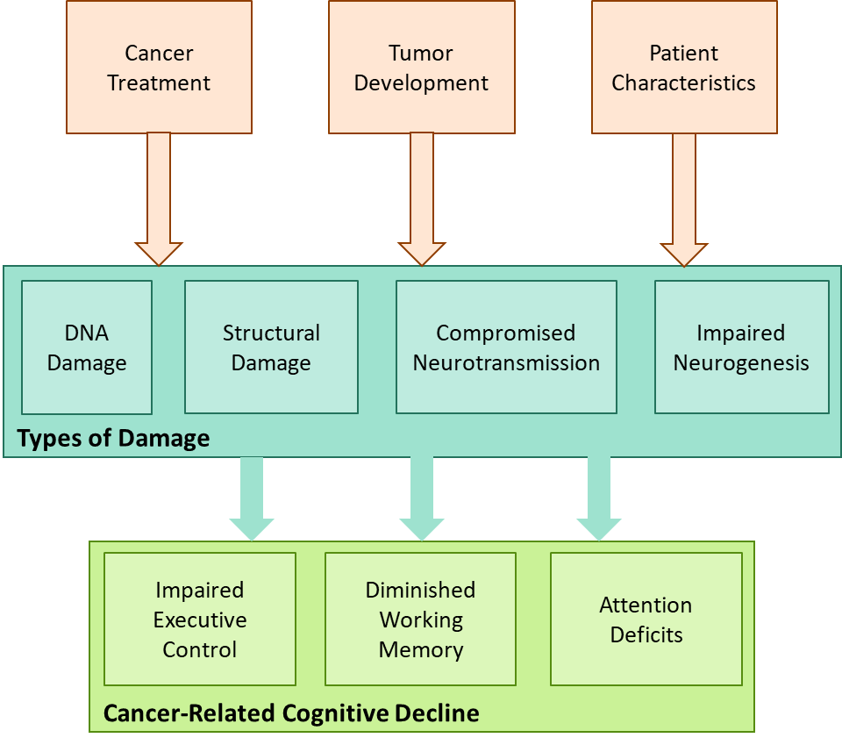

**The Role of Inflammation**

The early 2000s saw an explosion of CRCD research illustrating that while the potential causes of CRCD were extremely varied, many patients experience very similar cognitive deficits and physical symptoms. Hierarchical cluster analysis of cancer side effects established that cancer symptoms often had clusters for appetite loss, pain, fatigue, and attention deficits, which were markedly similar to the symptoms of animal sickness behavior, such as wasting, pain, decreased social and habitat exploration, and impaired learning (Cleeland et al., 2003; Lee et al., 2004). This comparison of cancer side effects to animal sickness behavior was especially important because of the magnitude of studies that had induced sickness behavior (rather than just assessing correlations). Most commonly, these sickness behavior studies injected either bacteria or purified pro-inflammatory biomarkers into small animals and established that intracerebral, intravenous, and subcutaneous administration could all induce an inflammatory response and sickness behavior (Lee et al., 2004). Thus, the potential for a similar role of inflammation in human cancer symptoms became a major focus in CRCD research (Tannock et al., 2004). The potential benefits of understanding the role of inflammation in CRCD cannot be understated, as there is a vast history of being able to treat inflammation, which may serve as an avenue for CRCD treatment (Keeney et al., 2018; Pang et al., 2021). By understanding the role and nuances of inflammation, there is hope to discover an avenue for CRCD treatment, providing a huge change in the quality of life for cancer patients and survivors.

Inflammation is a complex process, requiring extensive communication between different types of cells. When neural tissue is damaged, a foreign pathogen is discovered, or excess molecules are detected, a specialized group of macrophages, called microglia, are activated (Shabab et al., 2017). These activated microglia swarm to the target site to attack ‘suspicious’ or dead tissue and cells, all while signaling for aid with the release of small proteins, such as cytokines and chemokines (Shabab et al., 2017). Other cells that function in the neuroimmune response, such as neutrophils, lymphocytes, and astrocytes, can then swarm to help, all while releasing cytokines and chemokines of their own (Nguyen & Ehrlich, 2020). In patients with cancer, tumor cells have been known to have their own microenvironment, including immune cells, that can also release cytokines (Olson & Marks, 2019). Though the flood of cells and nutrients through inflammation is a crucial part of healing, balance is pivotal, and it is important to avoid having too many immune ‘cooks in the kitchen.’ Measuring the levels of certain types of chemokines and cytokines can provide a biomarker for what types of messages are being shouted through the immune system, and in turn, determine if there is a healthy balance in the inflammatory response. While some of these signaling proteins are anti-inflammatory, such as interleukin (IL)-5, others are pro-inflammatory, such as interferon-alpha (IFN-α) and tumor necrosis factor-alpha (TNF-α; Seruga et al., 2008). Even more cytokines can function as both pro- and anti-inflammatory, including IL-2, IL-4, IL-6, and IL-10, though some may lean more towards one type of response than the other (Seruga et al., 2008). When the central nervous system is repeatedly flooded by too many pro-inflammatory protein signals, neuroinflammation can become chronic, with damaging side effects to the surrounding tissue (Nguyen & Ehlrich, 2020). Cytokines are one of the most common inflammation signaling proteins, and they can routinely be obtained from blood serum or cerebrospinal fluid, so they make a convenient measure to assess the state of neuroinflammation (Nguyen & Ehlrich, 2020). More importantly, as purified cytokines have been shown to induce sickness behavior in animals, there is a theoretical background to assessing cytokine levels in CRCD.

Our understanding of the relationship between cytokines and CRCD has grown substantially over the last 20 years. Interestingly, one of the earliest forays into assessing this relationship came before the field fully shifted toward the possibility that inflammation could play a role as a mediator. In 2001, Capuron and associates evaluated the impact of immunotherapies that included IL-2 and IFN-α cytokines on patients’ scores from three domains of the Cambridge Neuropsychological Test Automated Battery, but found slightly contradictory results. While patients who received IFN-α immunotherapy only had significantly lower scores on the multiple-choice task, the IL-2 immunotherapy group had significantly lower scores on the spatial working memory task and the spatial planning task (Capuron et al., 2001). Surprisingly, a subgroup of patients who received both IL-2 and IFN-α immunotherapy actually performed better on the spatial planning task, leading researchers to question how these cytokines were either promoted or counteracted by other cytokines. This article laid the groundwork for illustrating that not all cytokines are cytotoxic and that there is a balance to be found between the neuroprotective and neurodegenerative components of inflammation. This balance was further highlighted in a paper often regarded as one of the first (well-known) studies to assess cytokine differences in CRCD. Meyers and associates (2005) reported that while higher levels of IL-6 were correlated with worse executive function on the Trail Making Test Part B, higher levels of IL-8 were correlated with better memory on the Hopkins Verbal Learning Test. In other words, the effects of an inflammatory response can differ based on the cytokines involved and the cognitive domain.

This dual, neuroprotective/ neurodegenerative nature of inflammation is also illustrated in subjective measures of CRCD, despite the difficulties with assessments. In a study evaluating blood serum concentrations of cytokines and performance on the Headminer™ neuropsychological test and the FACT-Cog, Cheung et al. (2015) reported that more severe subjective cognitive impairment was associated with higher concentrations of IL-6 (*B* = -0.92, *p* = 0.018) and interleukin-1 beta (IL-1β; *B* = -0.44, *p* = 0.001). On the neuroprotective side, every unit of IL-4 blood serum concentration was associated with a 0.95 increase in the FACT-Cog score (*p* = 0.022), indicating that IL-4 improved subjective CRCD (Cheung et al., 2015). It is worth noting, however, that while previous research raised the possibility that IL-8 could play a neuroprotective role, in this study, the relationship between FACT-Cog and IL-8 was not significant (Cheung et al., 2015). These results illustrate that the balance of the inflammation system is linked to both subjective and objective cognitive outcomes, but it has not yet been determined what this balance is, or how it can be achieved.

***The Damaging Effects of Inflammation***

The human body is largely composed of balancing systems within balancing systems, and the immune response is no exception. In a healthy body, cells perform actions that use energy, often in the form of electrons. When a cell completes a function, it uses an electron from a molecule and then releases the newly electron-deprived molecule, which is called a free radical, back into the system. Free radicals, such as molecules belonging to the reactive oxygen species (ROS), do not like being deprived of an electron, so will try to steal an electron from a different molecule. To prevent this chain of electron stealing, the body releases antioxidants, which scavenge excess ROS, keeping the body in balance. Oxidative stress occurs when ROS production expands past the capacity of antioxidants. This is important for inflammation, as free ROS activate microglia, triggering their functions as macrophages (an action that results in additional ROS byproduct) and their release of cytokines (McLeary et al., 2019). Tangpong et al. (2007) demonstrated that cytokines like TNF-α could also generate ROS, further perpetuating the inflammatory response. As the ratio of ROS to antioxidant molecules grows, the negative feedback loop of a healthy system is turned into a vicious spiral of chronic inflammation. This oxidative stress damages a cell’s mitochondria, causing mitochondrial dysfunction and apoptosis (Rummel et al., 2021). As this spiral of chronic inflammation and oxidative stress kills cells, fewer antioxidants are released, exacerbating the problem (Rummel et al., 2021). The damage from this process is severe enough that Wang et al. (2015) reported that oxidative stress is the leading cause of neuronal death. In cancer patients, this spiral is especially evident. Bagnall-Moreau et al. (2019) reported that cancer treatments like doxorubicin produce free radicals, triggering the oxidative stress spiral. Even when cancer treatments are unable to pass the BBB, the inflammatory biomarkers can infiltrate the immuno-privileged environment of the brain (Janelsin et al., 2012). This unchecked inflammatory response results in axonal damage, impairments in DNA translation, and structural damage to the hippocampus (Bagnall-Moreau et al., 2019; Schroyen et al., 2021). As similar damage was reported when assessing the direct effects of cancer treatment on CRCD, this provides a rationale for evaluating the role of inflammation with each factor impacting cognition, as depicted in Figure 2.

**Figure 2**

*The Role of Inflammation in Causing Cancer-Related Cognitive Decline*

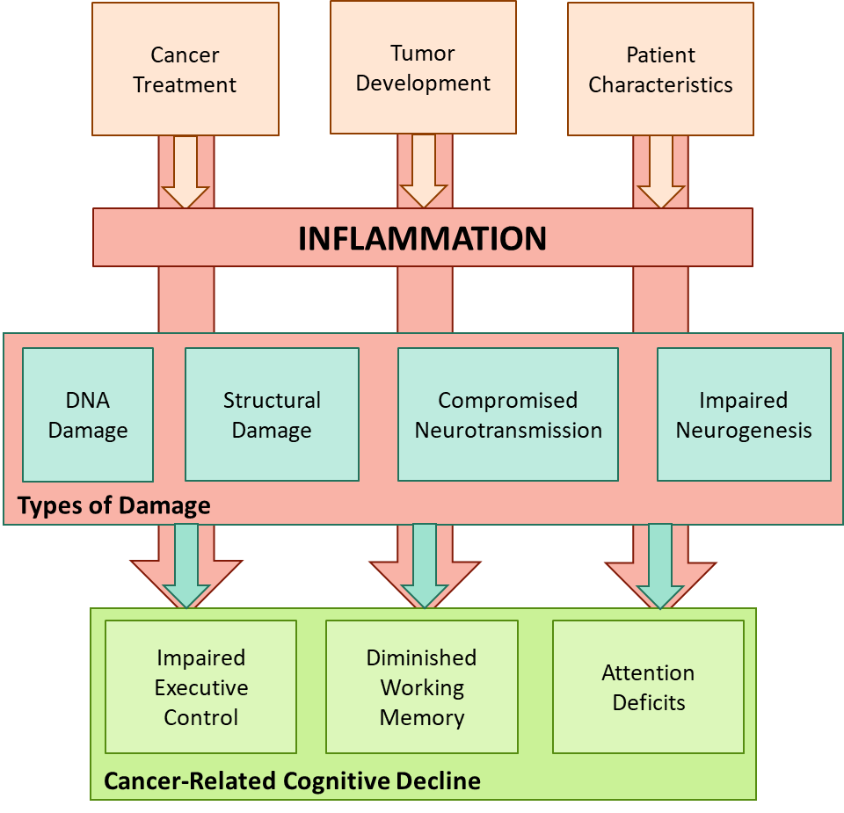

***Inflammation and Treatment Regimen***

As discussed previously, cancer treatment can impact CRCD bypassing the BBB and causing structural damage, impairing neurogenesis, and altering neuronal transmissions. One of the easiest places to assess how inflammation could be the vehicle driving cancer treatment impact is illustrated at the BBB. While only some chemotherapies can make it through the BBB, cytokines can pass through in a multitude of ways (Ren et al., 2017). As previously addressed, cytokines are such small molecules, they can passively diffuse through leaky regions of the BBB or actively enter at receptor locations through endocytosis (Ren et al., 2017). Most alarmingly, Rahman et al. (2018) illustrated that cytokines such as interferon-gamma (IFN- γ) and IL-17A could open junctions in the BBB, allowing larger molecules (including the chemotherapy agents) to enter the brain within 60 minutes of cytokine administration. With the alterations to BBB permeability, the influx of cytokines and chemotherapy can trigger microglial activation, oxidative stress, and inflammation throughout the brain, resulting in hippocampus volume loss (Ren et al., 2017; Ren et al., 2019). As the hippocampus is vital to learning and memory, the structural damage from the inflammatory response could be disastrous for CRCD. There is a burgeoning body of evidence to suggest that this flood of cytokines into the CNS does reduce cognitive function. In a 2013 study on breast cancer survivors, Kesler and colleagues reported that not only did patients who received chemotherapy have higher cytokine levels than controls, lower levels of IL-6 and higher levels of TNF-α were associated with lower left hippocampal volume. In fact, TNF-α, IL-6, and the interaction of these two cytokines accounted for 51.1% of the variance in left hippocampal volume (*p* = 0.02; Kesler et al., 2013). The authors connected this cytokine-driven damage to CRCD, as cytokine levels and left hippocampus volume explained 48.2% of the variance in total scores on the Hopkins Verbal Learning Test (*p* = 0.04). When considering that structural damage is just one way that cancer treatment has been linked to CRCD, explaining nearly half of the variance in CRCD outcomes is outstanding. However, as most current research focuses on linear relationships and associations, more mediation analyses will be necessary to determine if chemotherapy and cytokines are both impacting structural damage, and thus causing cognitive impairment, or if the relationship between structural damages from treatment and CRCD is mediated (or moderated) by inflammation.

Another potential route that inflammation could be driving treatment impact on CRCD is through the alterations in transmission. Cytokines have been shown to influence the synthesis and reuptake of neurotransmitters, such as serotonin, dopamine, and glutamate, hindering the ability of the central nervous system to pass information (Capuron & Miller, 2011). Lyman and associates (2014) proposed that the synaptic dysfunction from cytokines impairs impulse strength and long-term potentiation, resulting in memory deficits. Additionally, Gibson and Monje (2021) acknowledged that as cytokines play a role in dendritic pruning, a chronic inflammatory response could result in over-pruning and loss of branch complexity. To assess how these deleterious effects of cytokines may play a role in CRCD, Shi et al. (2019) administered rounds of chemotherapy to mice, collected blood serum cytokine levels, performed an MRI scan, assessed cognitive impairment in the Morris Water Maze Test, and dissected the brains of the mice. The authors found that chemotherapy increased levels of IL-6 and TNF-α, while reducing levels of IL-4 and IL-10, both in the blood serum and across the entire brain. Shi et al. (2019) reported that the increased levels of IL-6 and TNF-α correlated with worse cognitive performance and increased dendritic spine elimination. These results provide preliminary evidence that cytokines could be driving impairment by damaging neural pathways in animal models. This pattern may occur in human CRCD as well. In a multi-site study of 717 current cancer patients, Oppegaard et al. (2021) performed pathway impact analyses to assess which signaling pathways were significantly perturbed between groups with low and high scores on the Attentional Function Index. The authors related that of the 12 signaling pathways that were significantly more perturbed in the low-attention group, five pathways were related to inflammation, including the TNF, IL-17, and cytokine-cytokine pathways (Oppegaard et al., 2021). While correlation may not be causation, these patterns warrant performing more mediation studies to assess if the dysfunction caused by cytokines is the underlying mechanism behind cancer treatment CRCD.

The relationships between cytokines, neurogenesis, and CRCD are still largely unknown. However, through the comparison of CRCD to sickness behavior, we can evaluate this potential avenue for inflammation to impact cancer cognition. Liu et al. (2019) demonstrated that not only did the administration of IL-1 induce sickness behavior in mice, but chronic IL-1 production in the hippocampus inhibited neurogenesis. These findings are consistent with earlier studies, where IL-6, IL-18, and TNF-α could trigger the cell death of neural progenitor cells before they could differentiate into neurons (Lyman et al., 2014). As Nguyen & Ehrlich (2020) established that reduced neurogenesis correlated with memory impairment, there is a need for research that encompasses changes in cytokine levels, neurogenesis, and the domains of CRCD.

***Inflammation and Cancer Development***

As tumor cells trigger an immune response from the body and release their own inflammatory markers, the presence of tumors may induce oxidative stress, triggering an inflammatory response that causes CRCD (Wardill et al., 2016). In a longitudinal study on colorectal cancer patients, Vardy et al. (2015) reported that while there were significant differences in CRCD between cancer patients and healthy controls, there were no differences in composite cognition scores between the subgroups who were treated with chemotherapy and those who only required a surgery. Furthermore, cancer patients, regardless of treatment regimen, had significantly higher levels of cytokines than healthy controls (Vardy et al., 2015). However, when assessing the connection between cytokines and cognitive scores the authors also noted that while IL-2, IL-8, IL-10, and IL-12 were all associated with the Cambridge Neuropsychological Test Automated Battery processing speed scores, none of the associations were significant (Vardy et al., 2015). Rather than signifying a lack of a relationship, this is yet another instance that may be hampered by the difficulties in CRCD measurement.

***Inflammation and Patient Characteristics***

As humans are inherently varied and random, looking for causal relationships between inflammation and patient traits must be approached and interpreted tentatively. It is important to note, however, that this does not indicate a lack of importance, as searching for patterns in inflammation, patient traits, and CRCD may distinguish vulnerable populations and drive interventions. Based on our current knowledge, one population that may be especially vulnerable is older cancer patients, as age is frequently correlated with both subjective and objective measures of CRCD (Janelsins et al., 2022). This trend is not trivial, as Országhová and colleagues (2021) reported that age is one of the most established risk factors for CRCD. It is possible that this increased risk is due to higher levels of pro-inflammatory cytokines, as low-grade inflammation is frequently connected to the aging process (Michaud et al., 2013). There is also an added risk of comorbidity, as both age and inflammation are linked to other neurodegenerative disorders, such as Alzheimer’s disease (Mayo et al., 2021).

While there is less evidence indicating that other patient traits, such as ethnicity or gender, would have vastly different levels of inflammatory markers, the potential for population differences should not be ignored. Firstly, this lack of previous evidence could be partially due to a severe underrepresentation of minorities in cancer and CRCD studies (Kronenfeld et al., 2021). Disregarding the possibility of a minority-related difference in inflammation and CRCD could further inflate healthcare disparities. Secondly, as inflammation may be serving as a mediator in CRCD, we need to consider what factors can impact inflammation, especially factors that may be different between populations. Thus, future research is needed to address differences in genetic predispositions for inflammation, diet, exercise, hormones, healthcare access, sleep quality, and cognitive reserve.

**Cancer and Stress**

While inflammation has been at the forefront of potential underlying mechanisms that drive CRCD, it is not the only piece of the puzzle. There is an additional component that straddles the line of biological mechanisms and mental experiences, that is deeply connected to the inflammatory response – stress. Quite understandably, being diagnosed with cancer and receiving treatment can be an extremely stressful experience. The stress caused by cancer has been linked with anxiety, lack of sleep, and worse health outcomes (Cheung et al., 2012). On the flip side, stress, especially chronic stress, has been linked with cancer development (tumorigenesis), tumor malignancy, and cancer progression, creating a dangerous cycle between stress and cancer (Dai et al., 2020; Moreno-Smith et al., 2010). In addition to directly impacting cancer development (and the CRCD severity associated with the cancer itself) stress has been shown to exacerbate CRCD symptoms. For example, in a study on pre-treatment breast cancer patients, Aspelund et al. (2024) reported that stress significantly predicted CRCD (β = -0.52, *p* = 0.049). Altogether, this creates a cycle of stress and cancer feeding each other, accelerating cognitive impairment, as depicted in Figure 3.

**Figure 3**

*The Stress-Cancer Cycle*

The role of stress in cancer outcomes received a critical measure of legitimacy with the release of the fourth edition of the *Diagnostic and Statistical Manual of Mental Disorders* (DSM-IV), as illnesses, such as cancer, were recognized as preceptors of posttraumatic stress disorder (PTSD; French-Rosas et al., 2011). With a clinical threshold for evaluating cancer-related stress, researchers could compare CRCD across sub-groups of cancer patients. Hermelink and colleagues (2015) utilized these standards to assess the impact of cancer-related PTSD on error scores from a series of computerized attention tasks and found that PTSD symptoms significantly predicted error scores (β = 0.27, *p* = 0.004). In 2017, the authors completed a follow-up study that re-evaluated PTSD and CRCD after treatments were completed, and again a year after the patients’ first assessments. Interestingly, Hermelink et al. (2017) reported that in linear mixed-effect models, PTSD symptoms did not significantly predict CRCD, but in exploratory nonparametric bivariate analyses, there were significant correlations between PTSD and attention errors at both Time 2 and Time 3. While the authors did not go into detail on their exploratory analyses, their results do raise interest in an important, but not linear, relationship between stress and CRCD.

Even if it does not meet the threshold for PTSD diagnosis, stress can have substantial impacts on CRCD. Many studies have found a strong correlation between the FACT-Cog and the Beck Anxiety Inventory. Cheung and colleagues (2012) even found this correlation to be significant (*r* = –0.58, *p* < 0.001) for a large sample of Asian breast cancer patients, despite (well-founded) concerns that these American-normed assessments may not be as accurate in other cultures. In another study, Chen et al. (2021) illustrated that anxiety could mediate the relationship between cancer status and a neuropsychological verbal fluency task (β = 0.80, t = 3.85, p < 0.001). While these results are still very preliminary, it raises the possibility that the stress response may be one of the biological mechanisms driving CRCD.

***Stress and Inflammation***

Similar to how inflammation can be a driving force in neural damage, inflammation plays an integral role in the stress response. When cytokines are pushed into the system (as either a response to chronic stress or directly from the cancer development/ treatment), they can pass through the BBB and enter the hypothalamus. The hypothalamus then releases a hormone known as corticotropin-releasing factor (CRF), which floods the pituitary gland (Dai et al., 2020). In turn, the pituitary gland releases another hormone, the adrenocorticotropic hormone (ACTH), which travels to the adrenal cortex (Dai et al, 2020). This signaling pathway is known as the hypothalamus-pituitary-adrenal (HPA) axis, and is a crucial component of physiological regulation. When the HPA axis is activated, the adrenal gland will release multiple hormones, including corticosteroids, norepinephrine, adrenaline and cortisol. In a healthy system, cortisol stops the cycle by signaling the glucocorticoid receptors on the hypothalamus to stop releasing CRF (Tafet & Nemeroff, 2020). In an unhealthy system, however, the HPA axis is constantly flooded. At the same time, the sympathetic nervous system tries to trigger a fight-or-flight response by bombarding the adrenal gland. In essence, this flood overworks and damages the system. After extended exposure, the glucocorticoid receptors become desensitized to cortisol, so the hypothalamus continues to release CRF (Tausk, 2023). Additionally, the overproduction of corticosteroids alters the production of pro-inflammatory cytokines, increasing the amount passing through the BBB and activating the hypothalamus (Reiche et al., 2004). This cycle (depicted in Figure 4) is difficult to stop, and can cause substantial damage, especially to the hippocampus and prefrontal cortex (Dai et al., 2020).

**Figure 4**

*The HPA Axis and The Role of Inflammation*

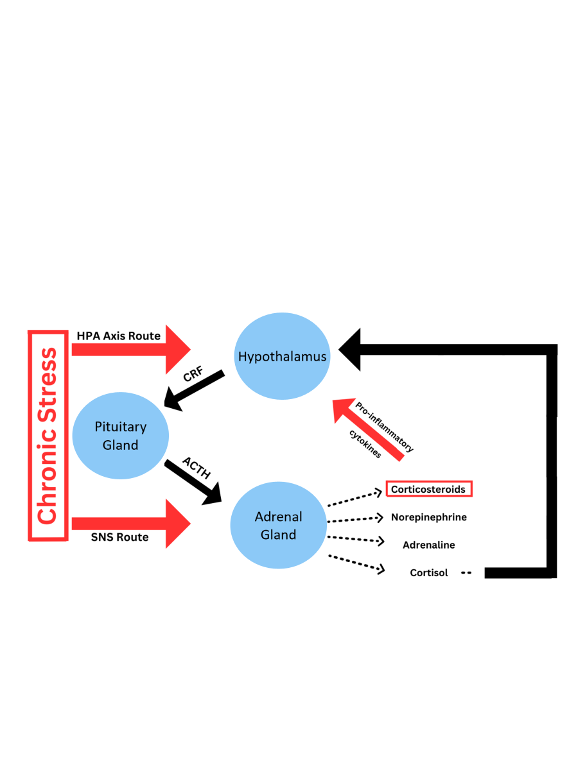

Considering the role of inflammation in chronic stress, it is perhaps unsurprising that there is a long history of connections between measures of stress and inflammatory biomarkers, such as cytokines (Cohen et al., 1999). It is important to note that this relationship is not restricted to chronic stress, as inducing acute stress has also been linked to an increased production of inflammatory biomarkers. For one example, Maes and colleagues (1998) compared cytokine levels and Perceived Stress Scale (PSS) scores in medical students at two time points, first at a baseline point, and then the day before a difficult exam (which was at least one month after their baseline timepoint). The researchers found that increased PSS scores were associated with an increased production of TNF-α, IL-6, IL-1Ra, and IFN-γ (Maes et al., 1998). In a multi-site project, Knight and associates (2021) used structural equation modeling to determine the nature of this relationship, and reported that PSS scores were associated with cortisol slope alterations, which were in turn associated with increased inflammation.

The intertwining of inflammation and stress has started to appear in cancer and CRCD research as well. Gilbertson-White and colleagues (2019) designed a study to evaluate the effect of inflammatory biomarker genotype on neuroimmune symptom severity in cancer patients, but (rather accidentally) found that PSS scores were more effective predictors of immune symptomology. There is reason to believe that stress may also be able to predict CRCD, as a series of studies applying multiple analytic approaches have found strong associations between perceived stress, cytokine production, and cognitive scores (Hennghan et al., 2018; Henneghan et al., 2020; Henneghan et al., 2021b). While these results are still preliminary, it has two powerful impacts. On a surface level, these results indicate that stress and inflammation may jointly impact CRCD. On a deeper level, the efficacy of stress in predicting immune changes provides a more attainable window into studying the biological mechanisms driving CRCD. Evaluating inflammatory biomarkers can be extremely costly, requiring extensive equipment and specialized training. Alternatively, administering a self-report questionnaire for perceived stress is both cost-efficient and accessible. Thus, by evaluating stress in CRCD research, we can still obtain meaningful information about biological changes.

**CHAPTER TWO: Assessing Cognitive Decline**

Over the last two decades, the field has developed a stronger understanding of what factors contribute to CRCD. Unfortunately, progress on this front has been severely handicapped by difficulties in CRCD measurement. One barrier stems from the lack of homogeneity, which has made the interpretation and applicability of results murky, further complicating a very nuanced topic. It is expected that there will be some heterogeneity, as CRCD can include dozens of types of cancer, hundreds of treatment combinations, and millions of individuals with their own unique combinations of genetics and characteristics. Though a necessary part of performing research, study designs for CRCD can drastically vary, differing in comparison groups, analyses, and length of assessment, leading to a stretched interpretation of CRCD. For example, while some projects began assessments at a cancer screening appointment, other studies evaluated survivors 10 years after treatment cessation, yet each extreme are expected to be measuring the same CRCD concept (Aspelund et al., 2024; Henneghan et al., 2018). In a final blow, what constitutes as CRCD is vague (due to a lack of diagnostic criteria), leading to an astoundingly wide variety of assessments. For just a few examples, some projects asked a patient’s family member how often they had noticed the patient struggle with a specific task, other studies recorded the number of words a patient could recall after a delay, while another study pulled cognition-related items from a fatigue task (e.g., “At the moment I feel heavy-headed;” Durán-Gómez et al., 2022; Janelsins et al., 2012; Yang & Hendrix, 2018). But despite the wide variety of cognitive domains, analyses, and time points, each study is assumed to be analyzing CRCD, making the interpretations of CRCD relationships even more convoluted. With this imprecise approach, it is difficult to determine if contradictory results, such as when inflammatory cytokines are linked to both improvements and decline on cognition tasks, are due to meaningful biological mechanisms, or faulty measurements (Capuron et al., 2001; Cheung et al., 2015). In a nutshell, CRCD is usually a very subtle shift in ability that results in an incredibly extensive impact on a patient or survivor’s life. But to understand what is causing CRCD, we need to capture that subtle shift. When combining the innate heterogeneity of CRCD with the widely varying series of measurements, it can be difficult to consistently capture the subtle shift in cognition. This leads back to the proposition introduced at the beginning of this paper: Can we trade our proverbial tractor for a spade, using more specific information about individuals to improve our understanding of the factors impacting CRCD?

First, we must clarify how the field may be inadvertently be using a tractor instead of a spade. As previously stated, the International Cancer and Cognition Task Force declared that objective measures, such as neuropsychological tasks, should be used for measuring CRCD (Wefel et al., 2010). These assessments often measure a participant’s response time (RT) when completing a task or trial, and make comparisons based on the average RT (Gaynor et al., 2022). While this approach has been used for many years, there are multiple complications with relying on mean RTs. One problem stems from using a point-estimate for a distribution that doesn’t represent the data. Mean and standard deviation are based on a normal distribution, but RT distributions are almost always positively skewed. The potential problem of relying on a normal curve to describe RT data is depicted in Figure 5. In this figure, the normal curve is traced in red, and quite noticeably fails to account for the main peak of the RT distribution. The mean for this normal curve would be around 400 ms, which is a visible overestimation of the actual trend in the data. Adding to this reliance on a point-estimate like the mean does not describe the actual pattern of the data. As stated by Schwarz (2001), “the decision to initiate and execute a specific overt response does not arise holistically, in an all-or-none fashion, but is rather preceded by a stage during which response-related information gradually accumulates over time,” (p.459). By relying on means, we fail to account for the mechanisms of the cognitive process.

**Figure 5**

*The Shape of Response Time Distributions*

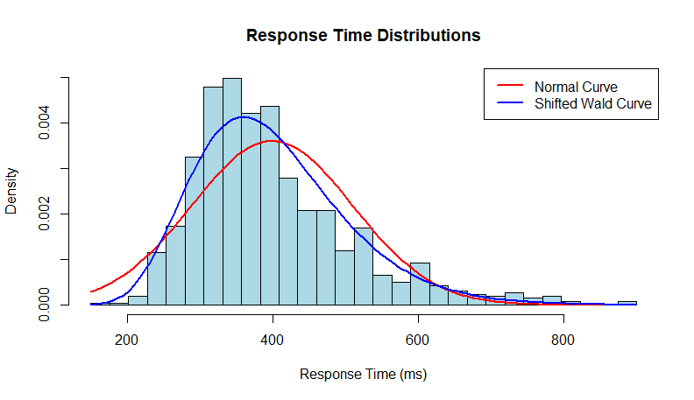

A second concern with the traditional, mean RT approach is seen in the reverse-inference problem. In forward inference, a researcher knows something about the cognitive processes, then measures the behavior (White & Kitchen, 2022). Alternatively, in reverse inference, a behavior is measured, then inferences are made about the cognitive processes (White & Kitchen, 2022). To demonstrate the potential problems with the direction of inference, we will discuss a metaphor about a teenager eating pizza. In forward inference, we would know that the teenager is hungry, then measure how many slices of pizza they eat. In reverse inference, we would measure how many slices of pizza the teenager eats, then make an assumption about their hunger. In this reverse inference scenario, we may see that the teenager only eats part of once slice, assume they aren’t hungry, then put away the food. We may then be shocked when the teenager becomes upset. While silly, this scenario demonstrates a problem that can arise in reverse inference: we may not be accounting for all the processes driving the behavior. In this scenario, we assumed that the number of slices eaten was only driven by hunger levels, and did not account for additional processes, such as the teenager’s preference for the type of pizza. In terms of the neuropsychological tasks used in CRCD research, the reverse-inference problem could occur when we see a slower average score on a task, and make an incorrect inference about the cognitive abilities of the participant (White & Kitchen, 2022). For example, if we see a higher mean RT on an attention task, we may incorrectly assume that they performed slower due to attention deficits, when the reality is they are being more cautious. Thus, if we are going to make inferences from a participant’s score, it is important that we account for as much of the underlying cognitive process as possible.

In summary, previous CRCD research may have been relying on point-estimates that don’t fully represent the data, while making inferences that don’t account for the underlying cognitive processes. Thankfully, there is a way to shift to an assessment approach that collects more information about each participant, creating a picture of the entire distribution, and providing information about the cognitive processes involved in CRCD. This proverbial spade is known as response time modeling.

**Response Time Modeling**

In RT modeling, rather than fitting a participant’s data with a normal curve, the distribution is fit with a model that is designed to account for the positive skew of the distribution, and more importantly, is represented by parameters that are based on the underlying cognitive processes. There are three main advantages of utilizing a RT modeling approach. First, RT modeling can account for all the behavioral data collected. In addition to fitting the data better, RT modeling can incorporate accuracy and error rates into the model (White & Kitchen, 2022). There are many scenarios where understanding a participant’s failure is more informative than their average for successful trials (e.g., when evaluating working memory). Accounting for all of the behavioral data allows researchers to make more accurate inferences about the underlying cognitive processes.

A second benefit is how RT modeling can help make connections between the theory driving the research and the actual data, with meaningful parameters. This in turn provides a more specific interpretation of the underlying cognitive processes. A wonderful example of this is seen in Ratcliff and associates (2006) study comparing memory and brightness discrimination between younger and older adults. When comparing the groups based only on their means, the older adults slower RTs would be interpreted as age-driven cognitive decline (Ratcliff et al., 2006). However, the authors also fit the data with a drift diffusion model. The main parameters in a drift diffusion model are nondecision time (accounting for the time needed to encode the stimulus), boundary separation (an indication of caution), and drift rate (indicating the information accumulation speed). When comparing the drift diffusion parameters between the younger and older adults, Ratcliff et al. (2006) found that the slower RTs stimmed from being more cautious and having longer nondecision time. As the older adults’ drift rates were not lower than the younger adults, there were no age-driven differences in processing abilities. This illustrates how using a model based in theory can provide specific, meaningful information about underlying cognitive processes, surpassing the information provided by traditional mean RT comparisons (Ratcliff et al., 2006).

A third benefit to RT modeling is the increased sensitivity in this approach, which can capture small differences in cognitive processes. As RT models are built to account for noise, which allows researchers to parcel out the changes in the actual cognitive processes. White and colleagues (2010a) demonstrated this in a lexical decision task about threatening words, where they evaluated threat bias with both traditional mean RT analysis and with a drift diffusion model. In the mean RT analysis, there was only a small, nonsignificant threat bias (White et al., 2010a). In the drift diffusion model analysis, the noise from individual differences was controlled for with the non-decision time and boundary separation parameters (White et al., 2010a). After this noise was controlled for, there was evidence of a consistent, significant effect of threat bias (White et al., 2010a). Considering that CRCD is a small but impactful shift in cognitive processes, the ability to control for noise and look specifically at the underlying cognitive processes could reshape CRCD research.

***Utilizing Response Time Modeling in Cancer Cognition***

Despite the benefits available in RT modeling, this approach has never been used to analyze CRCD. Shifting to evaluating neuropsychological tasks with RT modeling may be able to capture the slight changes in the cognitive domains that are driven by inflammation or stress. While any domain and task may benefit from this approach, the task that stands to be improved the most by RT modeling is the Attention Network Test (Fan et al., 2002). In this task, participants are presented with a string of arrows, and must press the arrow key that corresponds with the direction of the central arrow. Throughout the assessments, participants are presented with multiple types of trials, with a variety of signaling cues and types of information surrounding the central arrow. Traditionally, average RTs are compared across different trials, and the differences in these means are used as indicators of three attentional effects: executive control, orienting, and altering (Fan et al., 2002). Considering the issues with mean RT comparisons that have already been delineated, it may be unsurprising that there are frequent issues in finding any attentional effects. When designing the Attention Network Test, the creators reported that there was only moderate test-retest reliability for all three measures of attention (Fan et al., 2002). Executive attention had the highest correlation (0.77), followed by orienting (0.61), with alerting having the lowest correlation (0.52). Despite the issues with capturing the attentional effects, the Attention Network Test it is still regularly used in CRCD research (Gaynor et al., 2022). As an alternative to relying on these faulty effects, White and Curl (2018) promoted the use of a modified version of the drift diffusion model, known as the shrinking spotlight model. The shrinking spotlight model has parameters that represent how attention shrinks to focus on key information (hence the name). In their study, White and Curl (2018) demonstrated that the shrinking spotlight model could capture differences between the trials, and provide meaningful information about attentional processes. This begs the question of how utilizing RT modeling with the neuropsychological tasks used for CRCD could improve our understanding and be implemented in clinical settings.

While the benefits of RT modeling are undeniable, it is worth noting that the calculations for these models are non-trivial. It may be the computational difficulty of these models that has slowed the spread of their implementation. Despite the slow progress, RT modeling is beginning to be utilized to understand clinical disorders. In one study, diffusion models were used to determine that individuals with high anxiety perform slower because they were more cautious (White et al., 2010b). Pirrone and colleagues (2017) utilized drift diffusion modeling in a discrimination task similar to the study conducted by Ratcliff and colleagues (2006), but rather than comparing age groups, this study evaluated the differences between individuals with autism and neurotypical individuals. Interestingly, their results mirrored those found by Ratcliff and associates (2006), with caution and nondecision time driving the differences in RTs (Pirrone et al., 2017). These preliminary studies illustrate that RT modeling can improve our understanding when diagnosing individuals (and perhaps alter misconceptions surrounding clinical diagnoses). More research in clinical settings will be imperative before we can truly grasp the impact of a RT modeling approach. There is a critical need for understanding how RT modeling (specifically accumulator modeling) could track changes in a clinical setting across time. Currently, longitudinal studies with models like the drift diffusion model are exceedingly rare, with the few that do exist often focusing on the psychometrics of the model parameters (Zhang et al., 2014). Utilizing RT models to evaluate clinical outcomes (such as CRCD) across time may allow researchers to capture minute shifts in the processes. This could in turn be incredibly informative for understanding the factors that cause the shift. Until we can understand what drives changes in health outcomes (like CRCD), we will never be able to effectively treat or prevent these deficits. Thus, it is time to trade the tractors for spades, and determine if RT modeling will be able to capture slight cognitive changes, and account for how biological factors drive these changes.

**The Current Study**

In the current study, we will track cognition outcomes and stress scores in healthy undergraduate participants across the four weeks leading up to the end of the semester. In particular, we will measure attention, executive control, and working memory (the three domains most impacted by CRCD) with three neuropsychological tasks, which will then be analyzed with RT modeling. Five participants will take the Attention Network Test, which will be modeled with the shrinking spotlight model (Fan et al., 2002; Curl & White, 2018). To measure executive control, another five participants will complete the Open-Source Response Inhibition Task, which will be modeled with the Context-Independence Violation Bayesian Estimation of Ex-Gaussian Stop-Signal (BEESTS-CV) model built specifically for the task (He et al., 2022; Matzke et al., 2021). To measure working memory, a final five participants will perform a Dual N-Back task, which will be analyzed with a combination of the Linear Ballistic Accumulator model and systems factorial technology (Heathcote et al., 2015; Eidels et al., 2010). Each participant will complete the cognitive task and Perceived Stress scale at all four time points, so changes in the RT model parameters can be evaluated as the students approach final exams. The role of stress in driving these changes will be assessed. This psychometric approach will be crucial in establishing the ability of RT modeling to capture small shifts in cognition in clinical settings, as well as determine how biological mechanisms can drive these cognitive changes.